1)select sum(total_price) as Total_revanue from pizza_csv
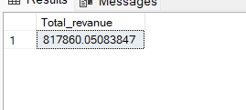
2) select sum(total_price)/count(distinct(order_id)) as avg_order_value from pizza_csv

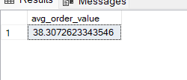

3) select sum(quantity) as Total_pizza_sold from pizza_csv
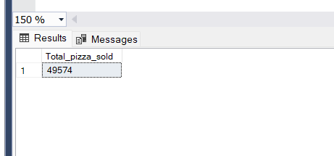

4) select count(distinct order_id) as Total_no_orders from pizza_csv

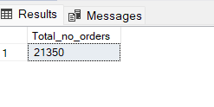

5) Select cast(cast(sum(quantity) as Decimal(10,2))/cast(count(distinct order_id) as Decimal(10,2)) as decimal(10,2)) as Avg_pizza_per_order from pizza_csv

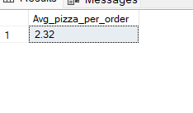

6) Daily trend for total orders
select datename(DW, order_date) as order_day , count(distinct order_id) as Total_orders
from pizza_csv
Group by datename(DW,order_date)
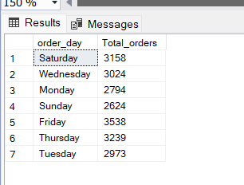

7) select datename(MONTH, order_date) as order_day , count(distinct order_id) as Total_orders
from pizza_csv
Group by datename(MONTH,order_date)
order by Total_orders desc
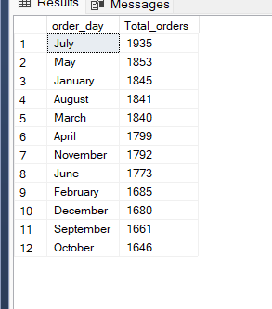

8)percent of sale
select pizza_category ,sum(total_price) as Total_sales,sum(total_price)*100 /
(select sum (total_price) from pizza_csv where month(order_date)=1) as "%sales"
from pizza_csv as Total_sales
where month(order_date)=1
Group by pizza_category
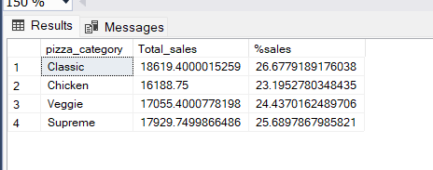

9)size wise sale in 1 quarter
SELECT pizza_size,CAST(SUM(total_price) AS DECIMAL(10,2)) AS Total_sales,
CAST(SUM(total_price) * 100 / (SELECT SUM(total_price) FROM pizza_csv
where DATEPART(QUARTER,order_date)=1) AS DECIMAL(10,2)) AS pct
FROM pizza_csv
where DATEPART(QUARTER,order_date)=1
GROUP BY pizza_size
ORDER BY pct DESC;

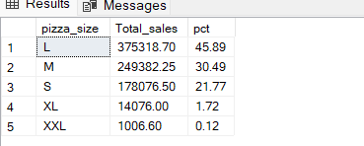

10) top 5 pizza
select top 5 pizza_name,sum(total_price) as total_revanue
from pizza_csv
group by pizza_name
order by total_revanue desc
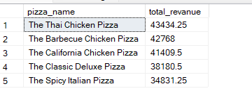

11) bottom 5 pizza
select top 5 pizza_name,sum(total_price) as total_revanue
from pizza_csv
group by pizza_name
order by total_revanue asc
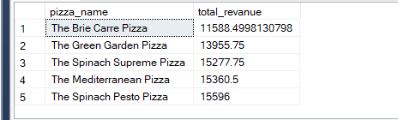

12)according to quatity top
select top 5 pizza_name,sum(quantity) as Total_quantity
from pizza_csv
group by pizza_name
order by Total_Quantity desc
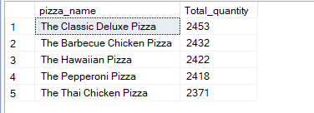

13)according quantity to bottom
select top 5 pizza_name,sum(quantity) as Total_quantity
from pizza_csv
group by pizza_name
order by Total_Quantity asc

